**Objective**: To reach an accuracy on the test set higher than 45%.

Modify the DNN_warmup notebook as follows:

* Add suitable hidden layers to the skeleton model in the notebook.
* Add early stopping to the training process in the section titled “Train the model”.

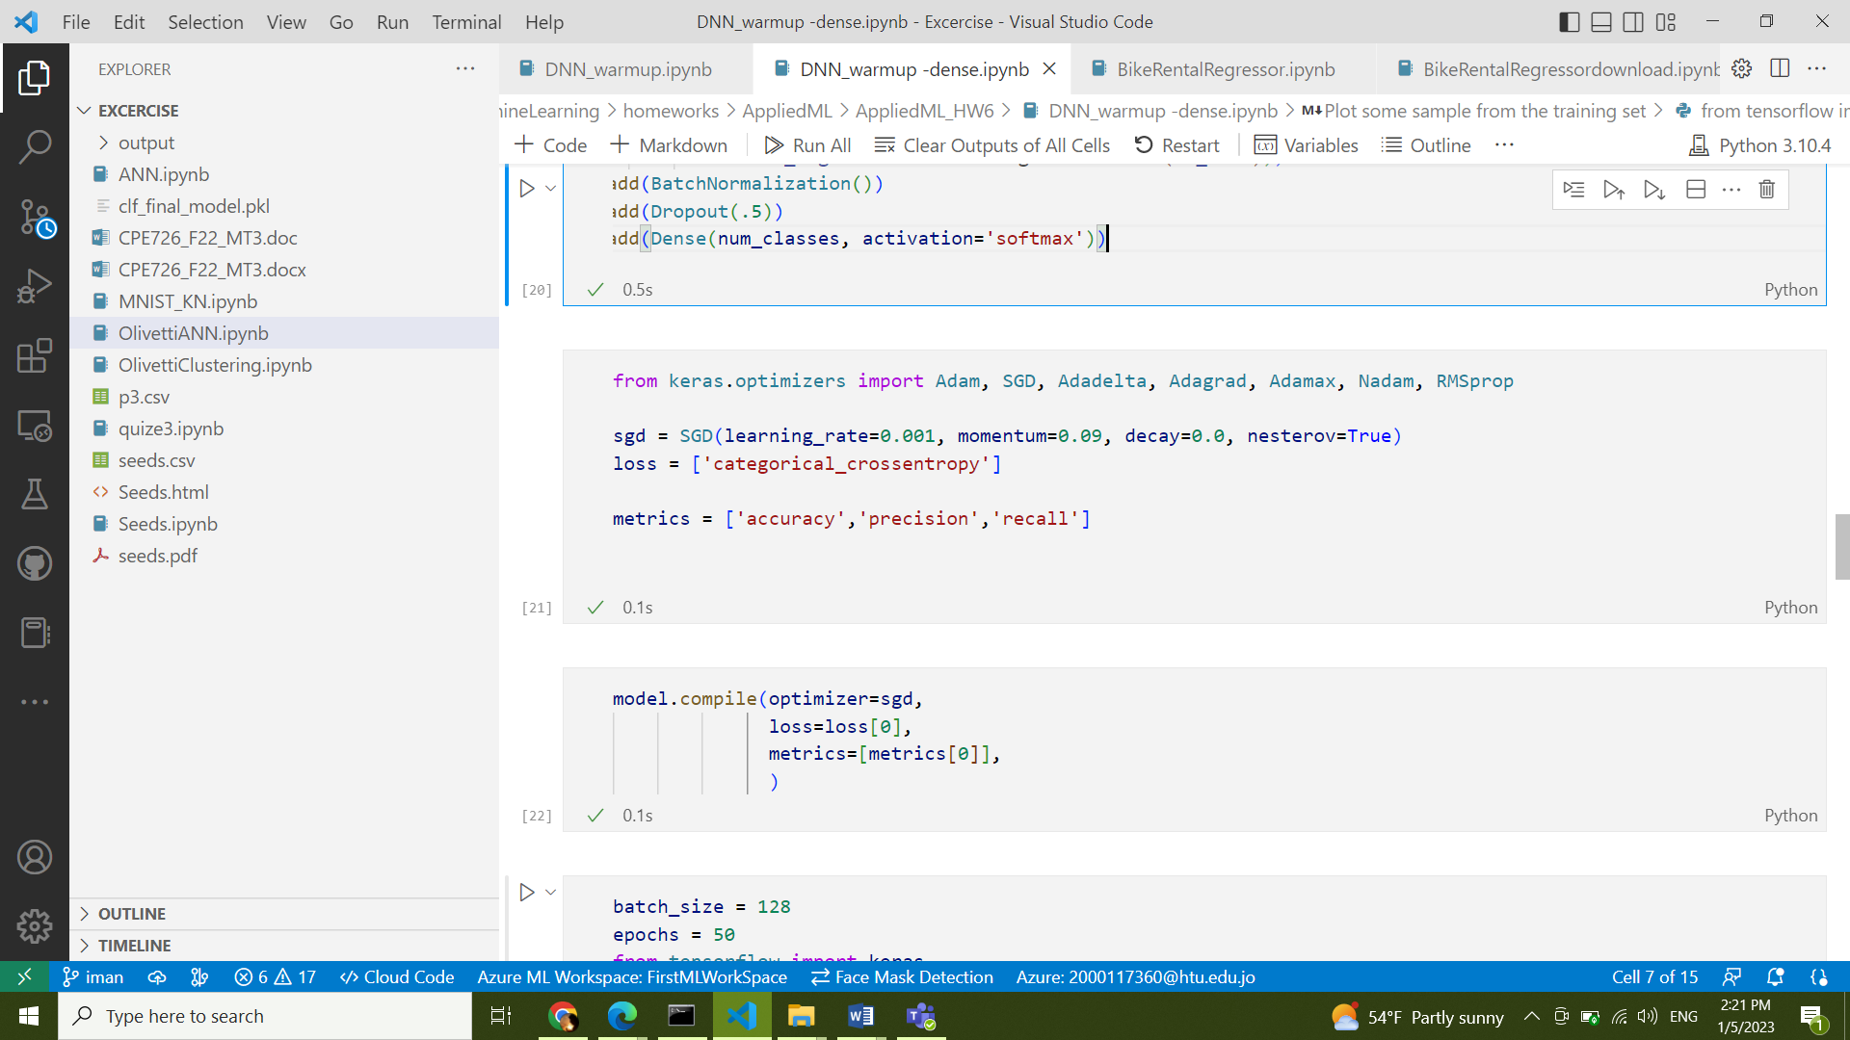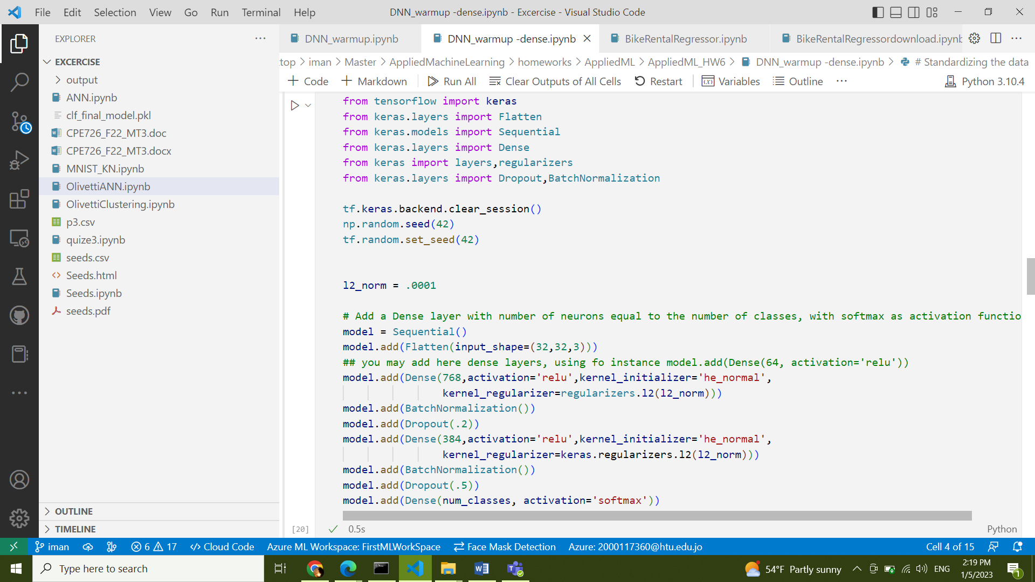

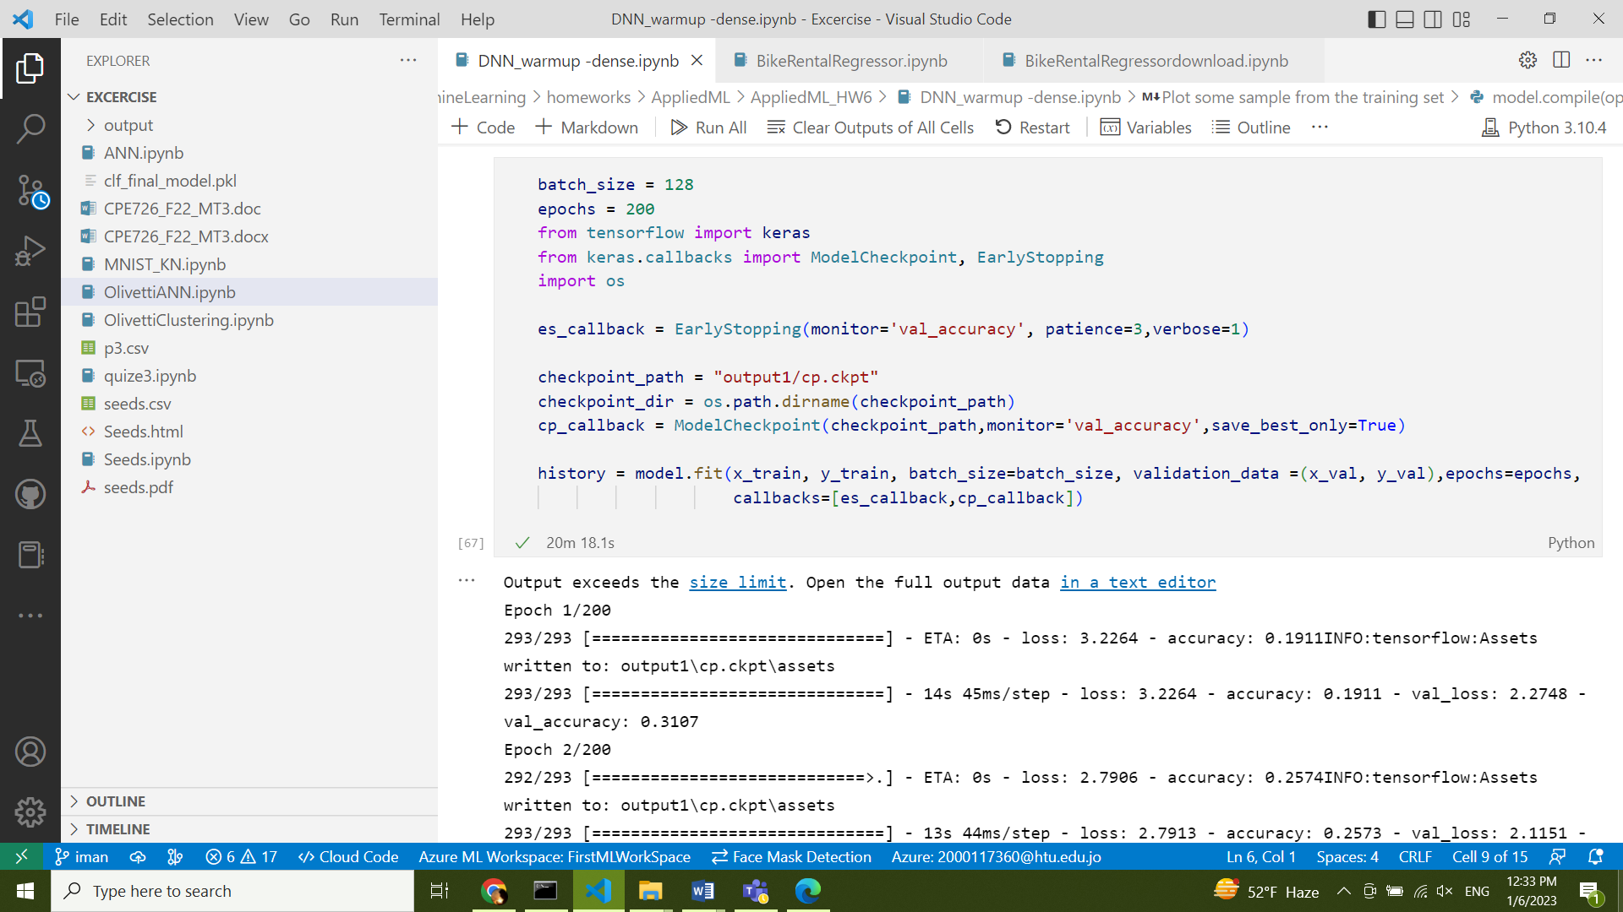

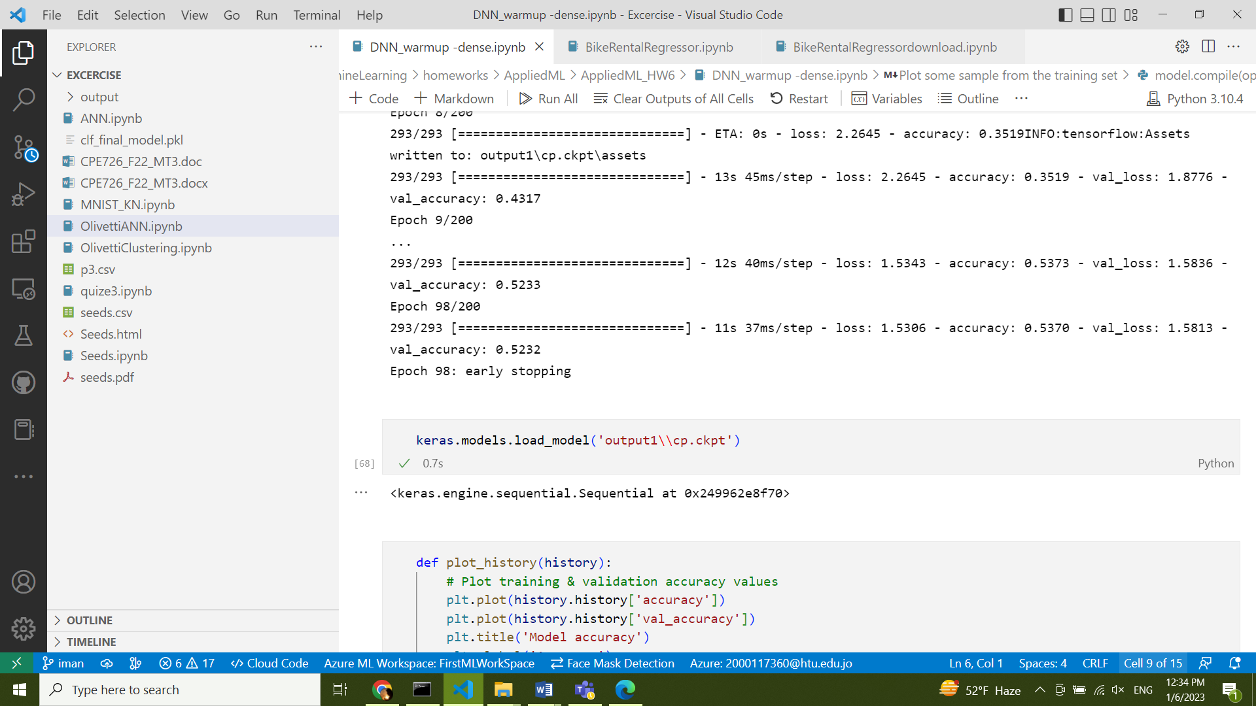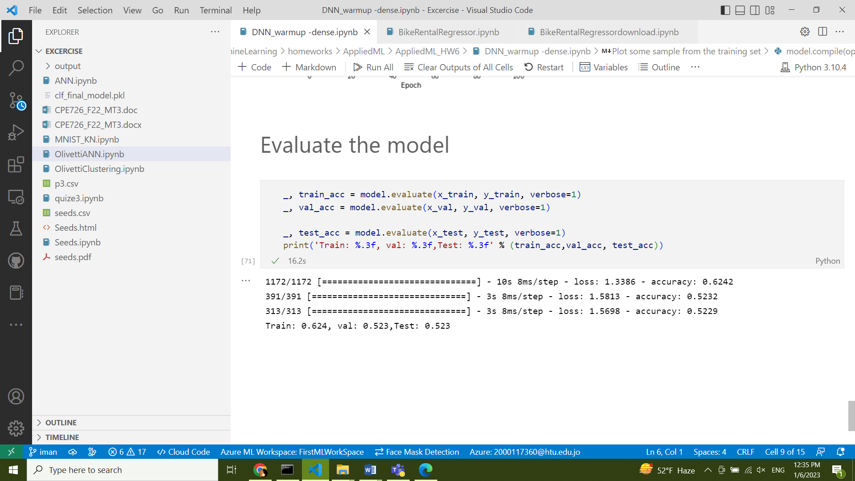

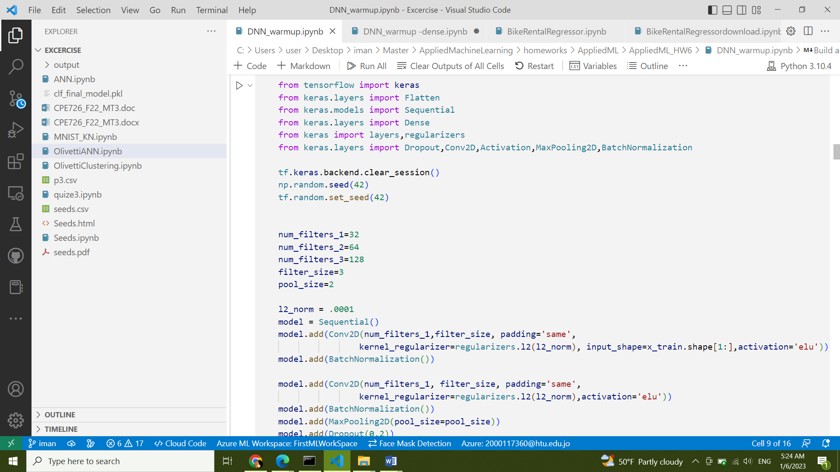**Bonus:** Improve your model to reach an accuracy higher that 50% of the test set.

